**Motif location analyses**

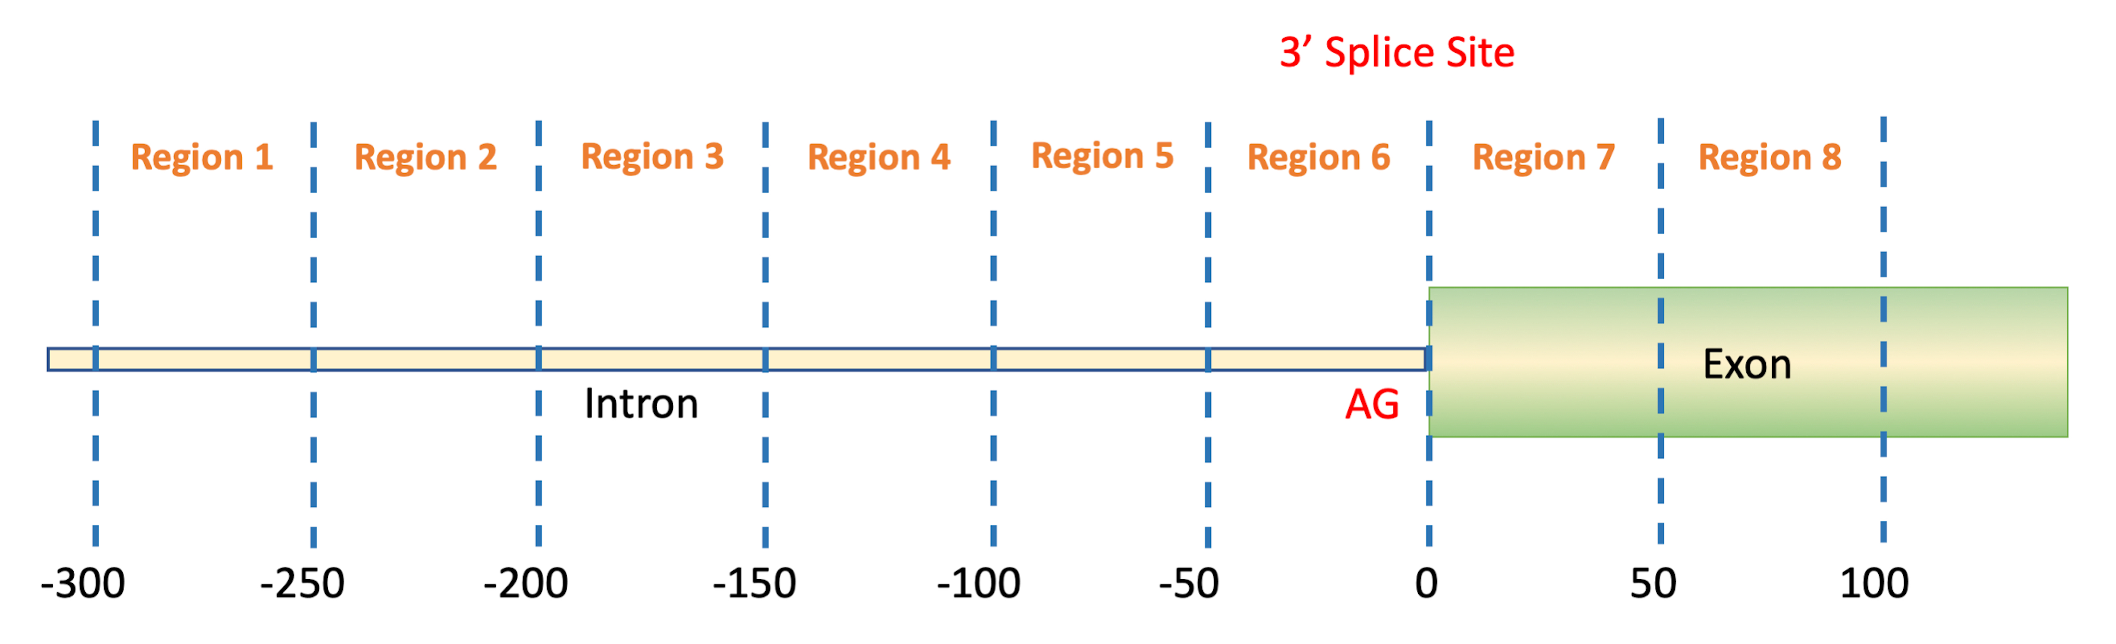

Eight regions are defined for the analyzed sequences. Region 1, Region 2, Region 3, Region 4, Region 5, and Region 6 are located in the intronic region at the upstream side of the acceptor dinucleotide, i.e., AG., Region 7 and Region 8 are located in the exonic region at the downstream side of the acceptor.

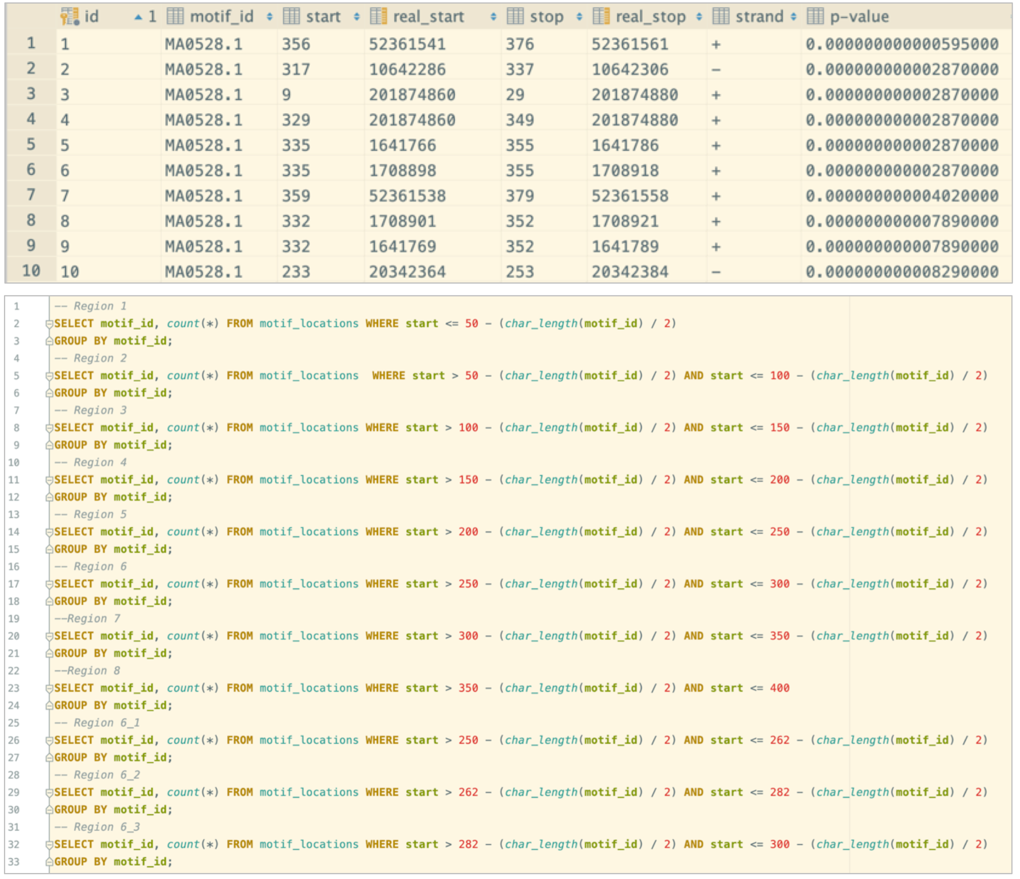

A snapshot from “motif_locations” table which stores FIMO output and SQL queries used for getting motif occurrences on the 8 regions around the splice acceptor sites

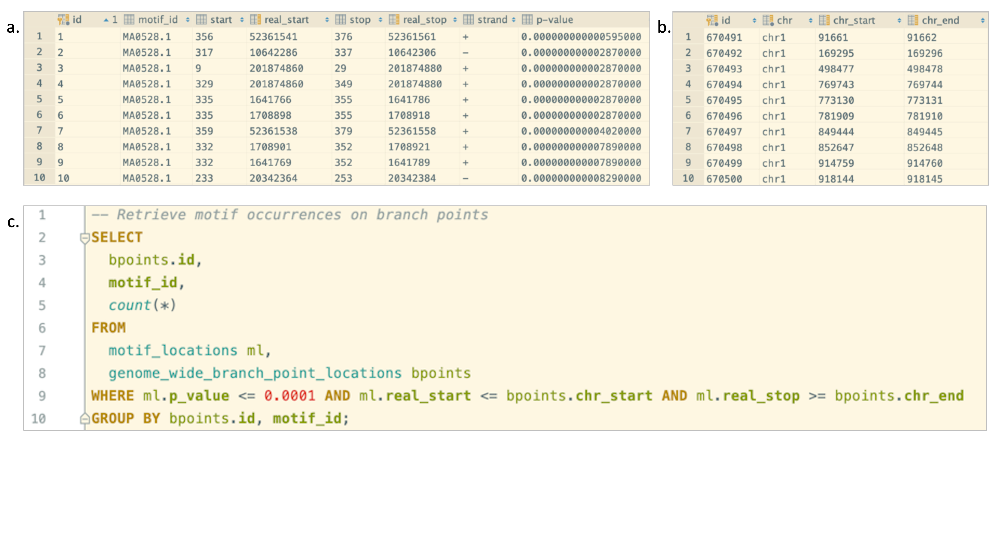

a. A snapshot from “motif_locations” table which stores FIMO output, b. A snapshot from “genome_wide_branch_point_locations” table which stores branch point locations published in “Genome-wide discovery of human splicing branchpoints” and SQL queries used for getting motif occurrences on the branchpoints.